Date: June 21, 2014

Projected Completion: August 21, 2014

|  |  |
| --- | --- |
| CIT 215 Case Study  Pittsburgh Auto Sales | Abstract  Herein lies an information systems analysis and design to computerize a used car lot’s business operations.  Michael Bowen, Tyler Chess, Doreen Esposito, Derek Fawcett, Antonio Gunter, Joshua Ibrahim, Barbara McGee, Scott McWilliams, John Smith, Joseph Yablinsky  Systems Analysis and Design |
|  |  |
|  |  |
|  |  |

**THE CASE STUDY – USED CAR SALES**

**Scenario**

A used car owner/dealer is beginning to have difficulties keeping track of business operations, car and truck inventory, as well as car and truck sales and realizes that it is time to computerize all of the business operations. The used car dealership has a variety of quality used cars and trucks for sale.

Currently, there are three full-time professional sales associates employed at the current store that the used car owner manages. There is also another full-time professional employed by the owner to keep track of all of the paperwork. This includes data and information for current and past customers and their purchases (sales), payroll/taxes, current inventory, as well as new car and truck purchases/sales (inventory). Additionally, the used car dealership employs a full-time mechanic that advises the owner on new car and truck purchases, as well as keeps paper records as to the work done on each vehicle prior to placing it on the sales lot.

The current manual system needs to be computerized to handle all of the various departments of the used car dealership.

Additionally, the store owner will be expanding with at least four used car dealerships within the state so the computerized information system must be able to handle the data and information as well.

Once the computer information system has been computerized, the used car owner would like to have a website developed in order to expand the business online.

**Assumptions**

* The car dealership doesn't have its own system priority board or IT department, so final decisions on the selection of systems would fall to the owner.
* The company can tolerate losses while the system is developed - they won't be closing down the dealership while waiting for the system.
* Implementation of the system would result in less time needed by employees to share and access data needed from other employees. For example, if one of the salespersons needed to know what kind of repairs were done on a particular car.
* The new system will improve data accuracy throughout the company.

**Research Basis**

Research Article for Cloud Computing and Small Businesses

This article discusses the main savings and advantages offered to a small business when they use cloud computing. A list comprised of six reasons is compiled for the reader.

* You’ll save on infrastructure – discusses how cost effective cloud computing is hardware wise.
* You’ll save on setup and management – discusses how most cloud providers have experienced technical support available.
* You’ll save on utilities – Cloud data is stored in shared servers, so a small business doesn’t have to worry about server costs.
* You’ll get better performance and more features – this part details how utilizing cloud computing can make software and OS’s that are normally out of the price range of smaller companies well within reach.
* Your company will become more agile – this sections reviews how cloud computing can be accessible not only for your company, but also for your customers.

Small Business Websites

This article is a newspaper clipping from 2011. The article is filled with some guidelines that the author recommends to set up an effective small business website. Steps like website goals, picking domain names, and choosing a hosting solution among others are covered in detail. The website goals section is straight forward. It asks, who is the target audience? How can you reach that audience? This section also clarifies that the website should offer its product outright, and that a visitor should “not be confused” when they are on the website.

The article also covers Hosting, finding a Web Developer, and SEO (Search Engine Optimization). To a small business owner, this article is a fantastic resource for getting started on a first website endeavor.

Azure's Success Shows Microsoft Gaining Ground in Cloud Computing

This article describes the growth of Microsoft’s Azure system in the marketplace. It notes that Azure’s share is increasing. This is attributed to several factors, including the fact that Azure allows third-party applications to be integrated into it, and it’s always-on SQL which allows for high availability. Azure is designed to work with existing software and allows a “hybrid” cloud structure, which means that it is easy to integrate with the company’s current systems but also makes it easy to begin using cloud computing. Cloud data back-up is also available. The article is overall optimistic in tone, but warns of several dangers: First, whether or not Microsoft will remain vendor-neutral; and second, whether they will maintain the open-pricing.

Microsoft Moves Dynamics GP 2013, Dynamics NAV 2013 to Windows Azure

This article notes that Microsoft has extended its Azure platform by using the cloud to deliver its Dynamics small business ERP software. Microsoft notes that this provides security, reliability, and privacy. The solution is available from both regular computers (desktops) and mobile devices, including smartphones. This is only available from partners and not Microsoft itself. Azure is also incorporating data solutions and is now capable of using the Big Data application Hadoop. Finally, the article notes that Azure is used by more than half of the Fortune 500 and is growing at over 1,000 new customers a day.

**System Service Request**

The System Service Request, or SSR for short, is one of the first deliverables produced through the application of system development life cycle practices. The SSR is a formal document used to request changes to a system, whether they be requests for upgrades or modifications to an existing system, or a request for development of an entirely new system. Members of management or project oversight boards will use the SSR as a starting point in determining whether or not to move forward with the system changes/upgrades/development by examining the problem statement and service request included on the document. They can then approve, both with or without possible changes, or reject the request entirely. The production of the SSR is usually a joint effort between analysts and the employees that have noticed the need for services to the systems.

Pittsburgh Auto Sales

1234 River Road

Pittsburgh, PA 15203

**System Service Request**

|  |  |  |  |  |  |
| --- | --- | --- | --- | --- | --- |
| REQUESTED BY | Jerry Gergich | | | DATE: | June 3, 2014 |
| DEPARTMENT | Management | | | | |
| LOCATION | Pittsburgh Auto Sales, Main Branch | | | | |
| CONTACT | Tel: 412-555-1234 Fax: 412-555-4321 email: jgergich@pas.com | | | | |
| TYPE OF REQUEST | | | URGENCY | | |
| New System | | | Immediate – Operations are impaired or opportunity lost | | |
| System Enhancement | | | Problems exist, but can be worked around | | |
| System Error Correction | | | Business losses can be tolerated until new system installed | | |
| PROBLEM STATEMENT | | | | | |
| With the expected expansion of the company to further locations and the proliferation of online sales, the current paper-based system for managing business operations, tracking inventory and keeping records of sales has become problematic and outdated. Some of the problems that need to be addressed are as follows: (1) The full time employee keeping track of paperwork has become overwhelmed, and thus is prone to errors; (2) Disconnects in communication exist between departments, using valuable employee time to acquire information; (3) Impending web sales will need electronic documentation to work with; (4) Expansion to further sites will only exacerbate the current issues with the paper-based records system. | | | | | |
| SERVICE REQUEST | | | | | |
| I request an extensive system analysis of current records and data management with the intent of designing an entirely new, electronic information system. The system must be able to completely replace all current paper-based systems, handling all sales information, inventory, employee payroll/taxes, current and past customer information and work done on cars in the lot. The system will need to allow different departments to access data quickly and easily, as well as allow for rapid business expansion and facilitate the implementation of the online store. These systems upgrade will not only allow the company to remain competitive, but will be crucial for the planned expansion. | | | | | |
| LIASON: | Michael Bowen Tel: 412-889-5863 email: mjbowen84@gmail.com | | | | |
| SPONSOR | Jerry Gergich, Owner | | | | |
| PARTICIPANTS | Michael Bowen, Tyler Chess, Doreen Esposito, Derek Fawcett, Antonio Gunter, Joshua Ibrahim, Barbara McGee, Scott McWilliams, John Smith, Joseph Yablinsky | | | | |
| ---------------------------------------------TO BE COMPLETED BY SYSTEMS PRIORITY BOARD------------------------------------------------------------ | | | | | |
| Request Approved | | ASSIGNED TO | Summer 2014 CIT 215 Development Group | | |
| START DATE | June 13, 2014 | | |
| Recommend revision | | | | | |
| Suggest user development | | | | | |
| Reject for reason: | | Reason for rejection | | | |

**Project Scope Statement**

The Project Scope Statement, or PSS for short, exists as a useful communication tool for the customers (the requestors of the system) to clearly see the design intent of the development team. The PSS clearly states the objective of the project, benefits to be gained from the successful completion of the project, and the deliverables the project aims to provide so that the customer and design team are able to gain a common understanding of the project scope. While the PSS can be very formal or more relaxed in nature, depending on the relationship between the customer and development team, it nonetheless conveys useful information by acting as a summary of the baseline project plan.

Pittsburgh Auto Sales

1234 River Road

Pittsburgh, PA 15203

|  |  |  |  |
| --- | --- | --- | --- |
| **Project Scope Statement** | | Prepared by: | Michael Bowen |
| Date: | June 21, 2014 |
| ***General Project Information*** | | | |
| **Project Name:** | Pittsburgh Auto Sales Computerized Information System | | |
| **Sponsor:** | Jerry Gergich, Owner | | |
| **Project Manager:** | Summer 2014 CIT 215 Development Group | | |
| ***Problem/Opportunity Information*** | | | |
| The use of paper records management has proved to be a hindrance to the growth and expansion of Pittsburgh Auto Sales. To facilitate expansion, in both physical space and into the e-commerce age, a new and improved method must be developed for storing and accessing records, inventory management and business management. | | | |
| ***Project Objectives*** | | | |
| To enable the company and employees to quickly and accurately maintain and access data about sales, inventory, payroll, customers and work done by mechanics. This will also lay the groundwork for the expansion of the business into further locations and web based sales. | | | |
| ***Project Description*** | | | |
| A new information system will be built to collect and store data and information for current and past customers and their purchases, payroll/taxes, current inventory, as well as new car and truck purchases/sales and information on the work done on the cars in the lot by the mechanics. The system will be the groundwork to allow for moving into online sales. | | | |
| ***Business Benefits*** | | | |
| Improved ability of the employees to access and share relevant information between departments. Improved accuracy of stored data for business operations. Internetworking between current and future sales locations. Groundwork laid for moving into online sales. | | | |
| ***Project Deliverables*** | | | |
| Information system analysis and design. Database, networking and online sales programs. Information systems documentation. Training procedures. | | | |
| ***Estimated Project Duration*** | | | |
| 10 weeks | | | |
|  | | | |
| ***Participatory Members*** | | | |
| Michael Bowen, Tyler Chess, Doreen Esposito, Derek Fawcett, Antonio Gunter, Joshua Ibrahim, Barbara McGee, Scott McWilliams, John Smith, Joseph Yablinsky | | | |

**INFORMATION TECHNOLOGY PROJECT MANAGEMENT**

**Expected Time Calculation Chart**

The expected time calculation chart uses the project evaluation and review technique (PERT) to formulate the estimated lengths of time needed to complete each discrete task of the project. The Expected Time Calculation Chart shows the optimistic, realistic, and pessimistic estimates for each activity. Using the formula [o + 4(r) + p / 6] the expected completion times are calculated for each activity, which is then entered into the Gantt Chart.

|  |  |  |  |  |
| --- | --- | --- | --- | --- |
|  | Time Estimate | | | Expected Time (ET) |
|  |  | (in days) |  | *o*+4(*r*)+*p* |
| Activity | *o* | *r* | *p* | 6 |
| 1. Research Hardware and Software | 10 | 14 | 18 | 14 |
| 2. Build Cloud Based Model | 5 | 7 | 9 | 7 |
| 3. Design Website | 6 | 7 | 8 | 7 |
| 4. Integrate Cloud and Website | 12 | 13 | 20 | 14 |
| 5. Test | 8 | 15 | 16 | 14 |
| 6. Train Employees | 10 | 14 | 18 | 14 |

**Sequence of Activities**

The sequence of activities are the tasks that need to be completed in order to complete the project. Also included are their predecessors, or tasks that need to be finished before the task in question can begin. These tasks and their durations are used to create the Gantt chart and network diagrams.

|  |  |  |  |  |
| --- | --- | --- | --- | --- |
| Task Name | Duration | Start | Finish | Predecessors |
| Research hardware and software | 2 wks | Fri 6/13/14 | Thu 6/26/14 |  |
| Build cloud based model | 1 wk | Fri 6/27/14 | Thu 7/3/14 | 1 |
| Design website | 1 wk | Fri 7/4/14 | Thu 7/10/14 | 1 |
| Integrate cloud and website | 2 wks | Fri 7/11/14 | Thu 7/24/14 | 2,3 |
| Test | 2 wks | Fri 7/25/14 | Thu 8/7/14 | 4 |
| Train employees | 2 wks | Fri 8/8/14 | Thu 8/21/14 | 5 |

**Gantt Chart**

The Gantt chart is a visual representation of the sequence and durations of the individual tasks of the project. It is also able to convey which tasks must be completed before advancing onto tasks further into the project. Using the Gantt chart, the project manager is able to keep track of the projects progress and determine if schedule adjustments need to be made and are possible.

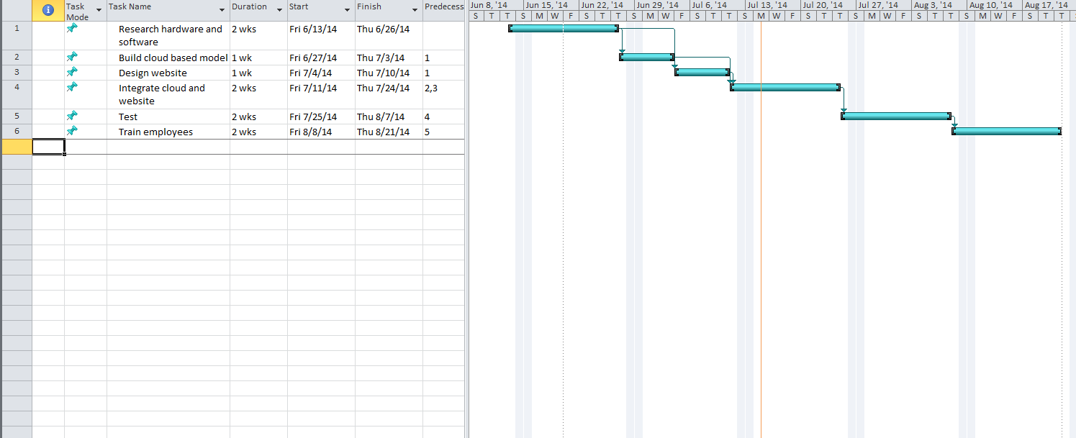

**Network Diagram**

The network diagram is visual representation of all the tasks required to complete a project, as well as how those tasks are interrelated. The network diagram does not visually depict the expected length of tasks like the Gantt chart, but it does easily show the critical path of the project and tasks which may include slack time.

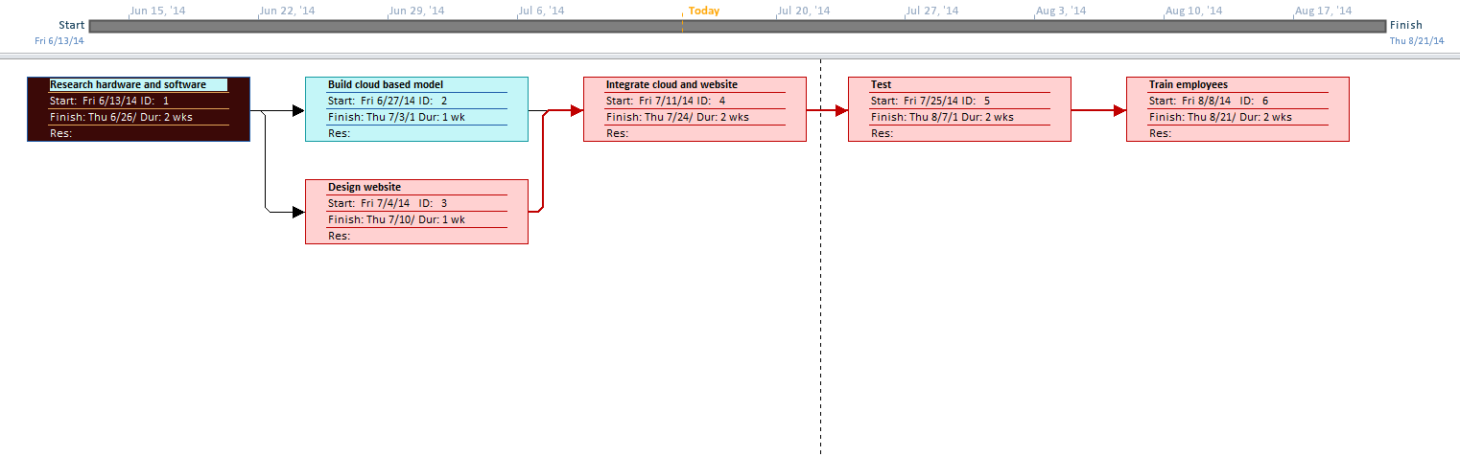

**HARDWARE/SOFTWARE/COMMUNICATIONS AND RELATED COSTS**

Hardware, software, communications and related costs are estimates on how much money will be required to design, implement and maintain the proposed information system. This data will be used in the economic feasibility study to determine whether or not the project is economically viable.

**Alternative 1 - Cloud based (PaaS) network system**

Microsoft Azure Assessment

Typical network/datbase setups can cost in the thousands and have yearly maintaince fees which can slow down a growing business expansion, but by using the Platform as a Service(PaaS) Infrastructure for cloud computing a business can cut costs and save time while devloping a new business infrastructure. PaaS, is a type of cloud computing system where the customer leases the equipment from a provider. We chose PaaS over Infrastucture as a Service(IaaS), because IaaS requires the company to provide their own equipment and could be costly. Additonally, Paas provides all the necessary material to host a database & website, and all the company will need to do is subcribe to Microsoft Azure. Azure is an all in one PaaS which offers a Virtual Desktop Network Service, Website Hosting, Virtual network, Sql Database and a Intenet service provider. By using Azure a business can effectively meet growth requirements by using the Azure cloud computing model and splitting the monthly cost over 4 companies or more. The cost of Microsoft Azure is based on current needs, a SQL server, website storage; 6 Personal computers running Azure Virtual machine for current employees; 10 computers for new employees running Azure Virtual Machine; a monthly GB usage of 300 gb, which would cost approximately $2,582 per month on a 12 month plan and only a .20 cent per hour increase on each additonal computer. Paas, is cost effective and meets expansion needs; although, we will still need to hire someone to design a website and desgin our database schema. The design and integration of the database to website will cost roughly $12,260 dollars. Development costs incurred by the Summer 2014 CIT 215 Development Group would be approximately $15,000 and user training would be $2,500.

Summary of costs:

One time costs $29,760

Recurring costs $ 2,582 per month

**Alternative 2 – In house (IaaS) network system**

|  |
| --- |
| Dell PowerEdge T110 II Server system Assessment |
| The in house network system would include a Dell PowerEdge T110 II Chassis with Cabled 4x3.5 Hard Drives, 10 Windows Server® 2012R2, Foundation Edition licenses, Factory Installed, 6 HP personal computers for a one-time cost of $ 3,032 for the Dell server with Windows Server and $4,524 for the HP personal computers. At this time it would be cost prohibitive to hire a fulltime IT employee to maintain the system. Dell provides remote consulting services but we feel that it would be better to have an onsite consultant assist in maintaining the system. The cost of this service would be approximately $1,500 per month. Internet service through Verizon would be approximately $95 per month and Quickbooks Online Plus at $64 per month will automate the auto dealers accounting, payroll and inventory. The design and integration of the database to website will cost roughly $12,260 dollars. Development costs incurred by the Summer 2014 CIT 215 Development Group would be approximately $20,000 and user training would be $2,500.  Summary of costs:  One time costs $42,316  Recurring costs $ 1,659 per month |

**Final Assessment**

Based upon our review of the two alternatives, we recommend Alternative 1, the Microsoft Azure cloud based system for Pittsburgh Auto Sales network system. Although the monthly recurring costs for this alternative will be approximately $900 more, we believe the system provides increased flexibilty for future growth of the auto dealer which will avoid additional costs for hardware upgrades. There is also a savings currently of approximately $13,000 of one time costs. As such, our feasibilty study is based on the implementation of the Microsoft Azure cloud based system.

**Process Modeling**

**Data Flow Diagram**

The data flow diagram, or DFD, allows an analyst to model how data will flow through a proposed system. The DFD consists of four main parts: data flows, data stores, processes and sources/sinks. By using these four symbols, analysts are able to diagram a conceptual version of how data is processed by a system and thereby gain a greater understanding of the system and its design.

The data flow symbol is represented as an arrow travelling between other symbols of the DFD. It represents the flow of data from one place to another, whether it be between a process to another process, process and a data store, or process and a source/sink. Data flows are data that are in motion between other entities.

The data store symbol is drawn as a rectangle with the right side missing and represents data at rest. Most of the time, data stores represent physical locations where data might be stored when not being worked on or modified. These places might be a computer hard drive or a file cabinet with physical records.

Processes are actions that work on and change data and are visually represented in the DFD by a rectangle with rounded corners. Processes are where the actions are performed on the data to make that data useful, whether it is to the user or to another process.

Sources and sinks are entities that reside outside of the formal system and are the origins or destinations of data. In DFDs, the sources and sinks are drawn as squares. These might represent customers, departments, managers or any other entity that will be the start or end point for the data in a system.

The DFD we selected for the system has 6 level 0 processes required to perform its overall goals. These processes are: Update Customer Data, Receive Interest in Car and Advise, Process Orders, Make Repairs, Make Sale and Pay Salesperson. These processes represent the high level functions that the system needs to be able to complete. Two of the processes, Update Customer Data and Make Repairs do no need broken down into component processes as they simply do what the process states. The other four processes, however, are more complex.

Process 2, Receive Interest in Car and Advise can be broken into two separate processes – Receive Interest in Car and Advise Customer. The first process is used inform the mechanic on what car is of interest to the customer and thus allow the mechanic to make recommendations on whether or not the car should be considered worth purchasing. The Advise Customer process then relays that data back to the customer who will make the decision on whether or not to buy the car.

Process 3, Process Order, can be broken down even more than process 2. It consists of 3 distinct processes – Generate Car Order, Send for Repairs and Update Inventory. The Generate Car Order process notifies the sales team that the customer is interested in buying and what car is to be bought. Meanwhile, the Send for Repairs process informs the mechanic that the car will be purchased so he/she and make the appropriate fixes. Update Inventory does just what it says, it updates the company’s inventory of cars by removing the car being bought from the current stock.

The Make Sale process, process 5 on the level 0 diagram can be deconstructed to include 5 separate processes. The Check Credit and Get Loan For Car Prices processes determine whether or not the customer will actually be able to pay for the car in question. Approve Sale gets the keys and title to the customer and sends approval further into the system for updating records. Generate Sales Document processes data for storage in the Master Sale File data store and Update Customer File updates the customer’s information to include the purchased car.

Pay Salesperson broken down involves 4 discrete processes. Get Sales Data interacts with the Master Sales File to provide pertinent data for paying employees. Get Commissions uses this data, as well as data from the Payroll/Taxes store to generate payment info. This data is then sent to the Pay Employee process, which actually delivers the money to the salesperson, and to the Update Payroll process, which updates the Payroll/Taxes data store accordingly.





**Conceptual Data Modeling**

**Entity-Relationship Diagram**

The entity-relationship diagram, or ER diagram, is a tool used by analysts to determine how data in a system relates to other data. It consists of two parts – the entities and the relationships.

Entities are discrete objects that can be represented as data. These can be people, places, events or concepts about which data needs to be maintained. Each entity will have attributes and identities. Attributes are the information that are pertinent to the system, while the identities are used to identify the entity. Entities are represented in the ER diagram by boxes containing the entity name any attributes and identifies the entity might have.

Relationships in the ER diagrams show how entities are related to one another. For example, an entity representing a school course can have many students related to it, but only one teacher. The relationships in an ER diagram are represented by lines connecting the entity objects with a verb phrase and with unique crows foot notation denoting what type of relationship exists between those entities.

Our ER diagram included entities for the Owner, Timecard, Employee, Salesperson, Mechanic, Service History, Automobile, Sale, Inventory and Customer and how these entities may related to each other.



**ECONOMIC FEASIBILITY STUDY**

**Part 1 – Tangible Benefits Worksheet**

This worksheet represents a summarized estimation of the individual benefits the company may anticipate following implementation of a new computerized system. The figures were determined based upon interviews conducted with the car lot’s owner, data manager, and mechanic, who are responsible for maintaining the current manual system that is utilized. An itemized, detailed explanation of benefits is included in the “Tangible Benefits” worksheet section of the workbook.

|  |  |  |  |  |  |  |  |  |  |  |
| --- | --- | --- | --- | --- | --- | --- | --- | --- | --- | --- |
| **TANGIBLE BENEFITS WORKSHEET** | | | | | | | | | | |
| **Pittsburgh Auto Sales** | | | | | | | | | | |
| *New Electronic Information System Project* | | | | | | | | | | |
|  |  |  |  |  |  |  |  | | Year 1 through 5 | |
| A. | Cost reduction or avoidance | | |  |  |  |  |  | | $ 7,500 |
| B. | Error reduction | |  |  |  |  |  |  | | 4,000 |
| C. | Increased flexibility | |  |  |  |  |  |  | | 10,000 |
| D. | Increased speed of activity | | |  |  |  |  |  | | 8,000 |
| E. | Improvement in management | | |  |  |  |  |  | | 15,500 |
|  | planning or control | |  |  |  |  |  |  | |  |
| F. | Other - Reduction in ad costs due to new website | | | | | | |  | | 1,000 |
|  |  |  |  |  |  |  |  |  | |  |
| **Total Tangible Benefits** | | | |  |  |  |  |  | | **$ 46,000** |
|  |  |  |  |  |  |  |  |  | |  |
|  |  |  |  |  |  |  |  |  | |  |
| A. Cost reduction or avoidance is the result of less time spent by the bookkeeper and mechanic | | | | | | | | | | |
| filling out paper forms and better inventory control. It is estimated that 10% of their time is | | | | | | | | | | |
| spent on these activities. | | | |  |  |  |  |  | |  |
| B. Error reduction is a result of wasted time correcting data entry errors by the employees. | | | | | | | | | | |
| C. Increased flexibility will result from faster organization of data and the use of that data. | | | | | | | | | | |
| D. Faster access to data will reduce costs through increased speed of most activities. | | | | | | | | | | |
| E. The owner will benefit from better analysis resulting in improved management and control. | | | | | | | | | | |
| F. The new website will result in lower advertising costs. | | | | | |  |  |  | |  |

**Part 2 – One-Time Costs Worksheet**

This worksheet represents the initial start-up costs the company can expect to pay for the development/implementation of the new computerized system. The figures were determined by the Summer 2014 CIT 215 Development Group. An itemized, detailed explanation of costs is included in the “One-Time Costs” worksheet section of the workbook.

|  |  |  |  |  |  |  |  |  |  |
| --- | --- | --- | --- | --- | --- | --- | --- | --- | --- |
| **ONE-TIME COSTS WORKSHEET** | | | | | | | | | |
| **Pittsburgh Auto Sales** | | | | | | | | | |
| *New Electronic Information System Project* | | | | | | | | | |
| A. | Development costs | |  |  |  |  |  |  | $ 15,000 |
| B. | New hardware | |  |  |  |  |  |  | - |
| C. | New (purchased) software, if any | | | |  |  |  |  |  |
|  | 1. Packaged applications software | | | |  |  |  |  | - |
|  | 2. Other __________________________ | | | | | |  |  | - |
| D. | User training | |  |  |  |  |  |  | 2,500 |
| E. | Site preparation | |  |  |  |  |  |  | - |
| F. | Other - Design and integration of web site | | | | | |  |  | 12,260 |
| **Total One-Time Costs** | | | |  |  |  |  |  | **$ 29,760** |
|  |  |  |  |  |  |  |  |  |  |
|  |  |  |  |  |  |  |  |  |  |
| A. Development costs consist of the cost incurred by the Summer 2014 CIT 215 | | | | | | | | | |
| Development Group to develop the Pittsburgh Auto Sales network. | | | | | | | | | |
| D. User training costs are costs associated with training provided by the Summer | | | | | | | | | |
| 2014 CIT 215 Development Group. | | | |  |  |  |  |  |  |
| F. Other costs include website development. | | | | | | |  |  |  |

**Part 3 – Recurring Costs Worksheet**

This worksheet represents the costs the company can expect to incur which are a result of the progressive development, maintenance, and use of the new computerized system. The figures were determined by the Summer 2014 CIT 215 Development Group. An itemized, detailed explanation of costs is included in the “Recurring Costs” worksheet section of the workbook.

|  |  |  |  |  |  |  |  |  |  |
| --- | --- | --- | --- | --- | --- | --- | --- | --- | --- |
| **RECURRING COSTS WORKSHEET** | | | | | | | | | |
| **Pittsburgh Auto Sales** | | | | | | | | | |
| *New Electronic Information System Project* | | | | | | | | | |
|  |  |  |  |  |  |  |  | Year 1 through 5 | |
| A. | Application software maintenance | | | |  |  |  |  | $ - |
| B. | Incremental data storage required: 20 GB x $50 | | | | | |  |  | - |
|  | (estimated cost/GB = $50) | | |  |  |  |  |  |  |
| C. | Incremental communications (lines, messages, …) | | | | | |  |  | - |
| D. | New software or hardware leases | | | |  |  |  |  | 30,984 |
| E. | Supplies |  |  |  |  |  |  |  | - |
| F. | Other __________________ | | | | | |  |  |  |
|  |  |  |  |  |  |  |  |  |  |
| **Total Recurring Costs** | | |  |  |  |  |  |  | **$ 30,984** |
|  |  |  |  |  |  |  |  |  |  |
|  |  |  |  |  |  |  |  |  |  |
| D. New software and hardware lease are for the Windows Azure platform. | | | | | | | | |  |
|  | | | | | | | | |  |
|  | | | | | |  |  |  |  |
|  | | | |  |  |  |  |  |  |
|  | | | | | | | | |  |

**Part 4 – Present Value Calculations**

This worksheet represents the present value calculations of all benefits and costs associated with implementation of the new computerized system. The figures are projected over a five-year period which gives indication of if and when a profit will occur for the company.



**Part 5 – Break-Even Analysis Graph**

This worksheet represents a visual representation of the company’s break-even point following implementation of the new computerized system. The amounts reflect expected sales revenue vs. all associated costs and at what point in time a profit can be realized.

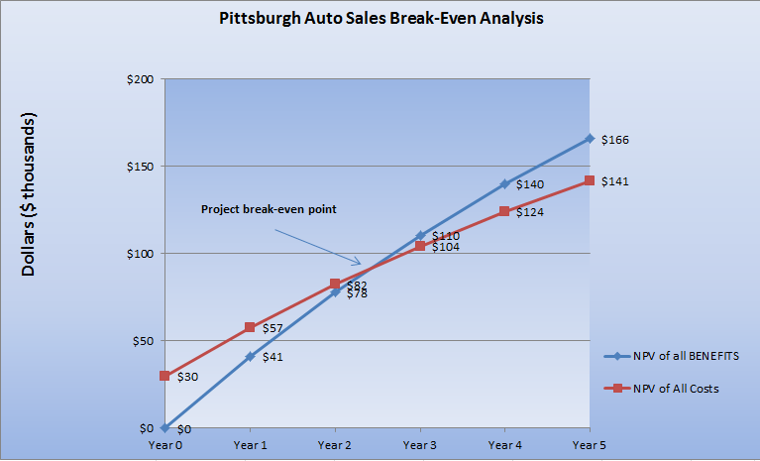

**Criteria/Weight Tables**

Criteria and weight tables represent a measure approach to comparing multiple different solutions for fulfilling the requirements of a system. The criteria, consisting of both requirements and constraints, allow the analysts to describe what the solution requires to fulfill its duties and what limits are imposed on the obtaining and maintaining of the solution. Weights are then assigned to the different requirements and constraints which are used to calculate the potential costs and benefits of each solution. The weight table gives a numerical representation of the solutions that can be compared to one another to assist in making an informed decision on which solution would be most appropriate for the system.

**Smartphones**

Two popular smartphones where picked for ease of use. We decided that the IPHONE 5 and The HTC M8 (Google Edition) were prime candidates based upon price; however, the deciding factors are on usage. Also, Depending on which smartphone solution is chosen will factor the outcome of the tablet as well because the application we will develop is only native to that OS.

**Criteria:**

|  |  |  |
| --- | --- | --- |
|  | IPHONE 5 | HTC M8 (Google Edition) |
| **Requirements** |  |  |
| Real time database/system access | yes | yes |
| Picture and video support | yes | yes |
| Battery Life | excellent | excellent |
| Display inventory data | yes | yes |
|  |  |  |
| **Constraints** |  |  |
| Development cost | $25,000 | $17,000 |
| Hardware cost | $200 | $200 |
| Time to operation | 1 day | 1 day |
| Ease of training | 0-2 days | 0-2 days |

**Weight Table:**

|  |  |  |  |  |  |
| --- | --- | --- | --- | --- | --- |
| ***Criteria*** | Weight | IPHONE 5 | | HTC M8 (Google Edition) | |
|  |  | Rating | Score | Rating | Score |
| ***Requirements*** |  |  |  |  |  |
| Real time database/system access | 20 | 4 | 80 | 5 | 100 |
| Picture and video support | 10 | 5 | 50 | 4 | 40 |
| Battery Life | 5 | 5 | 25 | 5 | 25 |
| Display inventory data | 15 | 5 | 75 | 4 | 60 |
|  | 50 |  | 230 |  | 225 |
| ***Constraints*** |  |  |  |  |  |
| Development cost | 20 | 3 | 60 | 4 | 80 |
| Hardware cost | 15 | 4 | 60 | 4 | 60 |
| Time to operation | 10 | 5 | 50 | 5 | 50 |
| Ease of training | 5 | 5 | 25 | 5 | 25 |
|  | 50 |  | 195 |  | 215 |
|  |  |  |  |  |  |
| *Total* | 100 |  | 255 |  | 250 |

**Tablets**

Tablet criteria are judged in the same manner as a smartphone due to minor differences; however, if IPHONE 5 is chosen then the IOS option must be chosen. Similarly, if the HTC M8 is chosen, then the ANDROID OS option must be selected.

**Criteria:**

|  |  |  |
| --- | --- | --- |
|  | IPAD AIR | Amazon Kindle Fire HDX 7 |
| **Requirements** |  |  |
| Real time database/system access | yes | yes |
| Picture and video support | yes | yes |
| Battery Life | excellent | excellent |
| Display inventory data | yes | yes |
|  |  |  |
| **Constraints** |  |  |
| Development cost | $25,000 | $17,000 |
| Hardware cost | $300 | $300 |
| Time to operation | 1 day | 1 day |
| Ease of training | 0-2 days | 0-2 days |

**Weight Table:**

|  |  |  |  |  |  |
| --- | --- | --- | --- | --- | --- |
| ***Criteria*** | Weight | IPAD AIR | | Amazon Kindle Fire HDX 7 | |
|  |  | Rating | Score | Rating | Score |
| ***Requirements*** |  |  |  |  |  |
| Real time database/system access | 20 | 4 | 80 | 4 | 80 |
| Picture and video support | 10 | 3 | 30 | 5 | 50 |
| Battery Life | 5 | 5 | 25 | 4 | 20 |
| Display inventory data | 15 | 3 | 45 | 5 | 75 |
|  | 50 |  | 180 |  | 225 |
| ***Constraints*** |  |  |  |  |  |
| Development cost | 20 | 3 | 60 | 4 | 80 |
| Hardware cost | 15 | 4 | 60 | 4 | 60 |
| Time to operation | 10 | 5 | 50 | 5 | 50 |
| Ease of training | 5 | 5 | 25 | 5 | 25 |
|  | 50 |  | 195 |  | 215 |
|  |  |  |  |  |  |
| *Total* | 100 |  | 205 |  | 250 |

**Antivirus**

**Criteria:**

|  |  |  |  |
| --- | --- | --- | --- |
|  |  |  |  |
|  | Kaspersky | Norton | McAfee |
| Requirements |  |  |  |
| Ability to schedule scans | Yes | Yes | Yes |
| Automatic scans | Yes | Yes | Yes |
| Up to date detection | Yes | Yes | Yes |
| Proven ability to prevent and remove viruses, malware, worms, etc. | High | Medium | Low |
|  |  |  |  |
| Constraints |  |  |  |
| Cost of software | 59.95 / year | 49.99 / year | $34.99 |
| Cost of service subscription | Free | Same | Same |
| Tax on system hardware during scans | Reduced when memory low | Low | Medium |

**Weight Table:**

|  |  |  |  |  |  |  |  |
| --- | --- | --- | --- | --- | --- | --- | --- |
| ***Criteria*** | Weight | Kaspersky | | Norton | | McAfee | |
|  |  | Rating | Score | Rating | Score | Rating | Score |
| ***Requirements*** |  |  |  |  |  |  |  |
| 1. Ability to schedule scans | 5 | 5 | 25 | 5 | 25 | 25 | 125 |
| 2. Automatic scans | 5 | 5 | 25 | 5 | 25 | 25 | 125 |
| 3. Up to date detection | 5 | 5 | 25 | 5 | 0 | 5 | 25 |
| 4. Proven ability to prevent and remove viruses, malware, worms, etc. | 35 | 5 | 175 | 3 | 105 | 1 | 35 |
|  | 50 |  | 250 |  | 155 |  | 310 |
| ***Constraints*** |  |  |  |  |  |  |  |
| 1. Cost of software | 20 | 18 | 360 | 20 | 400 | 20 | 400 |
| 2. Cost of service subscription | 10 | 10 | 100 | 10 | 100 | 10 | 100 |
| 3. Tax on system hardware during scans | 20 | 20 | 400 | 20 | 400 | 10 | 200 |
|  | 50 |  | 860 |  | 900 |  | 700 |
|  |  |  |  |  |  |  |  |
| *Total* | 100 |  | 1110 |  | 1055 |  | 1010 |

**Firewall**

According to BusinessDirectory.com, requirements are "constraints, demands, necessities, needs, or parameters that must be met or satisfied, usually within a certain time frame", while a constraint is an "element, factor, or subsystem that works as a bottleneck. It restricts an entity, project, or system... from achieving its potential... with reference to its goal". Microsoft defines a firewall as "software or hardware that helps prevent hackers and some types of malware from getting to your PC through a network or the Internet. It does this by checking the info that's coming from the Internet or a network and then either blocking it or allowing it to pass through to your PC."

The requirements for the firewall purchase for Pittsburgh Auto Sales would want to have customizable security settings, protection from outside influences, have minimal impact on connection speeds, and would need to be accessible in the cloud. Customizable security settings are a nice feature because Pittsburgh Auto Sales would be handling a lot of personal financial information from its customers', therefore it would definitely need the protection from outside influences. As with any other company, Pittsburgh Auto Sales would want minimal impact on connection speeds to process sales order more efficiently. Another plus with each of the companies is that they each can be used in the cloud.

The constraints for the firewall purchase would be the cost of the hardware, the ease of installation, and the training time. The cost of the hardware ranges from $680 to $725. All three companies offer easy downloads, although there is some training needed with configuration for two of the companies. These firewall purchase requirements and constraints will help the IT team at Pittsburgh Auto Sales determine which company will best fit their needs.

**Criteria:**

|  |  |  |  |
| --- | --- | --- | --- |
|  | Symantec Endpoint | Bit Defender | Panda Cloud |
| **Requirements** |  |  |  |
| 1. Customizable security settings | Yes | Yes | Yes |
|  |  |  |
| 2. Protection from outside influences | Yes | Yes | Yes |
| 3. Minimal impact on connection speeds | Yes | Yes | Yes |
| 4. Can be used in the cloud | Yes | Yes | Yes/remote access |
|  |  |  |  |
| **Constraints** |  |  |  |
| 1. Cost of firewall hardware | $725 | $710 | $680 |
| 2. Ease of installation | Easy download/10 PCs | Easy download/10 PCs | Easy download/10 PCs |
| 3. Training time | none needed | some for configuration | quick configuration |

**Weight Table:**

|  |  |  |  |  |  |  |  |
| --- | --- | --- | --- | --- | --- | --- | --- |
| ***Criteria*** | Weight | Symantec Endpoint | | Bit Defender | | Panda Cloud | |
|  |  | Rating | Score | Rating | Score | Rating | Score |
| ***Requirements*** |  |  |  |  |  |  |  |
| 1. Customizable security settings | 10 | 4 | 40 | 4 | 40 | 5 | 50 |
| 2. Protection from outside influence | 20 | 5 | 100 | 5 | 100 | 5 | 100 |
| 3. Minimal impact on connection speed | 10 | 5 | 50 | 4 | 40 | 4 | 40 |
| 4. Can be used in cloud | 10 | 4 | 40 | 4 | 40 | 5 | 50 |
|  | 50 |  | 230 |  | 220 |  | 240 |
| ***Constraints*** |  |  |  |  |  |  |  |
| 1. Cost of hardware | 10 | 3 | 30 | 4 | 40 | 5 | 50 |
| 2. Ease of installation | 25 | 5 | 125 | 5 | 125 | 5 | 125 |
| 3. Training time | 15 | 5 | 75 | 3 | 45 | 4 | 60 |
|  | 50 |  | 230 |  | 210 |  | 235 |
|  |  |  |  |  |  |  |  |
| *Total* | 100 |  | 460 |  | 430 |  | 475 |

**Input Form Design**

Following is a mock-up of a potential input screen users of the new system would be using. The screen shown is an example of a screen that would allow the user to update a specific vehicles service history. It was drawn up in Microsoft Visual Studio, but the aesthetics can be reconfigured as needed.

Once the user enters the vehicle identification number (VIN) into the appropriate input field, the system will automatically populate the other vehicle information fields with the data corresponding to that specific automobile. The user will then be able to update the service history by filling out the additional fields. Fields filled by the user are light, whereas fields filled by the program are slightly grayed out. In this case, the mechanic name and location would be imported from saved data once the Mechanic’s employee ID was entered and the total cost would be calculated once the parts cost and labor cost fields were filled.

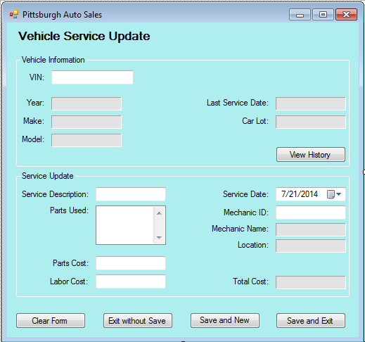

**Output Form Design**

Below is an output form generated by the system that represents the sale of a specific automobile. It includes a multitude of pertinent information, nearly all of which would be pulled from data stored within the system. The user would only need to enter the order number of the sale to generate the output form.

The form includes data on the vehicle sold, the customer who bought the vehicle, the employees who sold and serviced the vehicle and financial information regarding the sale. This form is designed to be printed and signed by the owner as a final approval of the sale and stored as a hard copy.

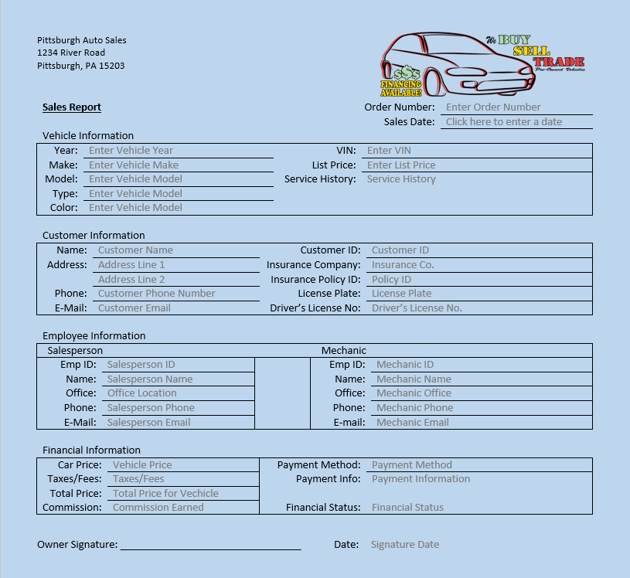

**Database Table Design**

Following are some possible database table designs to represent certain object information that will be tracked and stored by the information system. They have been populated with some mock data to serve as a more visual example. In each of the tables, the primary key identifier is double underlined and any foreign keys are single underlined. The database tables were designed using the Entity-Relationship diagram from early in the report. The arrows represent the fact that more information would be added.

First is an example of information to represent an automobile. It includes fields for the VIN, year, make, and model. It also includes foreign keys for customer ID and employee ID. The idea here being that, once the car is sold, it would be linked to a specific customer and salesperson.

|  |  |  |  |  |  |  |  |
| --- | --- | --- | --- | --- | --- | --- | --- |
| Automobile |  |  |  |  |  |  |  |
| VIN | Type | Year | Make | Model | Color | Customer ID | Order Number |
| 1X2XX34X56X789100 | Sedan | 2010 | Ford | Fusion | Blue | 000025 | 100-000-01 |
| 2Y3YY34Y67Y891012 | Coupe | 2007 | Chevy | Cobalt | White | 000103 | 100-001-06 |
| ↓ | ↓ | ↓ | ↓ | ↓ | ↓ | ↓ | ↓ |

Next is our idea of what a customer object may look like. A customer includes fields for customer ID, name, two address fields, phone number and email address.

|  |  |  |  |  |  |
| --- | --- | --- | --- | --- | --- |
| Customer |  |  |  |  |  |
| Customer ID | Full Name | Address | City_State_Zip | Phone | E-mail |
| 000025 | John Q. Doe | 999 Elm Street | Pittsburgh, PA 15218 | 412-555-9876 | [doejq@hotmail.com](mailto:doejq@hotmail.com) |
| 000103 | Jane Miller | 456 Steel Ave | Pittsburgh, PA 15212 | 412-555-2222 | [millerj@gmail.com](mailto:millerj@gmail.com) |
| ↓ | ↓ | ↓ | ↓ | ↓ | ↓ |

One more example is our possible representation of a vehicle’s service history. The service history includes a vehicle’s VIN as the primary key and the employee ID of the mechanic as a foreign key. Other fields for pertinent data include date serviced, part number, part description and labor cost.

|  |  |  |  |  |  |
| --- | --- | --- | --- | --- | --- |
| Service History |  |  |  |  |  |
| VIN | Date Serviced | Part No. | Part Description | Labor Cost | Emp ID |
| 1X2XX34X56X789100 | 5/20/2014 | BEA12345 | Ball Bearing | 99.95 | 0012 |
| 1X2XX34X56X789100 | 4/29/2014 | SHO98765 | Rear Shocks | 312.54 | 0006 |
| 2Y3YY34Y67Y891012 | 5/5/2014 | WIN23432 | Windshield | 275.14 | 0012 |
| ↓ | ↓ | ↓ | ↓ | ↓ | ↓ |

**System Implementation and Operation**

The systems implementation and operations portion of a project is made up of seven major activities. The first activity is coding, which according to our book, Essentials of Systems Analysis and Design, "is the process through which the physical design specifications created by the design team are turned into working computer code by the programming team (p 321)." For the Pittsburgh Auto Sales project, these include input forms used for entering information crucial to the working processes of the business, such as sales information, output reports that are used, for example, in the financial end of the business, and database tables which can be used for the record keeping aspect of the business, such as customer information.

The next part of systems implementation and operations is the testing process through which these forms and database tables are tested individually, then as parts of programs, and finally as part of the system. After these modules and programs have been tested positively, they can then be installed.

Concise documentation, another part of systems implementation and operations, must be maintained for all modules and programs as "the code itself spells out much about the program's logic, the meaning of data and variable, and the locations where data are accessed and output (p321)."

After the modules and programs are installed into the system, training must begin for all the employees of Pittsburgh Auto Sales. This can be done by providing user guides, manuals, and on-site training. Employees will be taught how to access user friendly on-line help sites to expedite troubleshooting.

Maintenance of the information system for Pittsburgh Auto Sales will be an ongoing process through the life of the system. Once maintenance requests are received, they can be transformed into changes by redesigning and implementing them again. These steps will help keep the information system for Pittsburgh Auto Sales running as smoothly as possible for the continued growth and success of the business.

**Overall Summary and Overall Recommendations**

To the Management of Pittsburgh Auto Sales:

The Summer 2014 CIT 215 Development Group as per your System Service Request has taken on the task of planning, analyzing, designing and implementing a computer based system for your business that will alleviate the problems you stated in such System Service Request. Attached is our Project Scope Statement that outlines the problem/opportunities, project objectives and description and the business benefits as well as the deliverables. We estimate the project duration will be no longer than ten weeks.

We have attached a Gantt Chart and Network Diagram for you to visualize what steps will be taken and how they will progress. We have conducted extensive research on developing a computer based system for you and explored two alternatives. Based upon our review of the two systems we are recommending that the company implements the Microsoft Azure cloud based system. The processes we have modeled for your new cloud based system are shown in the attached Data Flow Diagrams. As you can see from our Tangible Benefits Worksheet, we expect that this system will benefit the company by cost avoidance, error reductions, increased flexibility and improved management and control by approximately $46,000.

The Microsoft Azure cloud based system along with the development of your website will have a one-time cost of $29,760 and yearly recurring costs of $30,984. These costs are outlined in our report with detailed explanations. We have conducted an Economic Feasibility Analysis of these benefits and costs and have estimated through our Break-Even Analysis that the company’s cash flow will break even in approximately 2.4 years. As you can see by the Break-Even Analysis chart attached in our report, benefits from implementing this system will far outweigh the costs after this two year period.

We have also done extensive research for you to incorporate smartphones and tablets for use in your business. We have explored several brands based on criteria we felt necessary for your operations and weighed the benefits of each. Based on our research we recommend the I Phone 5 smartphone and the IPad Air tablet.

We recommend the use of a firewall for your cloud based system as well as an antivirus software program to prevent unwanted intrusions. Based on your systems criteria we recommend the Panda Cloud firewall which has remote access and the Kaspersky antivirus software.

**REFERENCE LIST**

1. Beaty, Donald L. "Cloud Computing 101." *ASHRAE Journal* 55.10, (2013) 88-93. Web.
2. Business Dictionary, BusinessDictionary.com, 2014, Web Finance, Inc, 07 July 2014 What's a Firewall, Microsoft, windows.microsoft.com, 07 July 2014.
3. Harbaugh, Logan G. "Six Reasons To Use Cloud Services For Small Business." PC World 30.1 (2012): 30. Business Source Premier. Web. 21 June 2014.
4. Hernandez, Pedro. “Microsoft Moves Dynamics GP 2013, Dynamics NAV 2013 to Windows Azure.” eWeek. Page 10. 6/19/2013
5. "How Much Does a Database Design Service Cost?" Free Database Design Price Quotes. N.p., n.d. Web. 22 June 2014.<<http://www.costowl.com/b2b/design-services-database-cost.html>>.
6. "How Much Does a Website Cost?" *Executionists Blog*. N.p., n.d. Web. 22 June 2014.<<http://www.executionists.com/blog/how-much-does-a-small-business-website-cost/>>.
7. "Introducing Azure." *Intro to Azure*. N.p., n.d. Web. 22 June2014. <<http://azure.microsoft.com/en-us/documentation/articles/fundamentals-introduction-to-azure/>>.
8. Lundquist, Eric. “Azure's Success Shows Microsoft Gaining Ground in Cloud Computing.” eWeek. Page 3. 10/28/2013
9. "No Upfront Costs. Pay Only for What You Use." *Azure Pricing Calculator*. N.p., n.d. Web. 22 June 2014. <<http://azure.microsoft.com/en-us/pricing/calculator/>>.
10. "Run Your Entire Business with QuickBooks." *Accounting Software for Small Business*. N.p., n.d. Web. 22 June 2014. <<http://quickbooks.intuit.com>>.
11. "Selecting Your Database Platform." *Information Services and Technology*. N.p., n.d. Web. 22 June 2014.<<http://ist.berkeley.edu/is/database/services/selecting_a_platform>>.
12. Stewart, John. "Small Business Websites." Enterprise/Salt Lake City 40.37 (2011): 9. MasterFILE Premier. Web. 21 June 2014.
13. Valacich, Joseph, Joey George and Jeffrey Hoffer. *Essentials of Systems Analysis & Design.* 5th ed. New Jersey: Pearson, 2012. Print.

Smartphone/Tablet References

1. "The 10 Best Laptops." *PCMAG*. N.p., n.d. Web. 06 July 2014.
2. "The Best All-in-One PCs." *PCMAG*. N.p., n.d. Web. 06 July 2014.
3. "Buy Now HTC One | HTC United States." *HTC*. N.p., n.d. Web. 08 July 2014.
4. "How Much Does It Cost to Make an App?" *Howmuchtomakeanapp.com*. N.p., n.d. Web. 06 July 2014.
5. "The IPhone 5s Review." *RSS*. N.p., n.d. Web. 06 July 2014.
6. "Android Benchmarks." *- Geekbench Browser*. N.p., n.d. Web. 06 July 2014.
7. "HTC One M8 Camera Test Results (photos) - CNET." *CNET*. N.p., n.d. Web. 08 July 2014.

Antivirus References

1. <http://www.av-comparatives.org/wp-content/uploads/2014/01/avc_sum_201312_en.pdf>
2. http://usa.kaspersky.com/products-services/home-computer-security/anti-virus/#creativeID1232
3. <http://home.mcafee.com/store/antivirus-plus>
4. <http://us.norton.com/antivirus/>
5. <http://blog.outletpc.com/knowledge-base/which-antivirus-program-will-work-best-for-me-norton-mcafee-trend-micro-kaspersky/>
6. <http://www.pcmag.com/article/print/254982>

Firewall References

1. <http://www.bitdefender.com/business/>
2. Burke,John (Nov 11, 2011) The Pros and Cons of a Cloud-Based Firewall retrieved July 4, 2014 from <http://www.networkworld.com/article/2221089/infrastructure-management/the-pros->
3. <http://www.pandasecurity.com/usa/enterprise/solutions/cloud-office-protection/>
4. <http://www.symantec.com/products/computer-security-software>
5. Williams, Mike (August 28, 2013) Best business antivirus: 8 top paid security tools for smsll business retrieved from http://www.techradar.com/news/software/applications/best-business-antivirus-8-top-paid-security-tools-for-small-business-1170097/2#articleContent